Maximising the leverage of existing knowledge could reduce research waste in applied ecology and conservation

Matthew J. Grainger1*, Friederike C. Bolam2, Gavin B. Stewart2, Erlend B. Nilsen1

1Norwegian Institute for Nature Research, P.O. Box 5685 Torgarden, 7485, Trondheim, Norway

2Modelling Evidence and Policy Research Group, School of Natural and Environmental Sciences, Ridley Building 2, Claremont Road, Newcastle upon Tyne NE1 7RU, UK

*corresponding author: matthew.grainger@nina.no

*Where research does not lead to benefits to society, it may be considered a waste of resources, especially when publicly funded. A formal assessment of the accumulated knowledge prior to research approval would reduce the waste of already limited resources caused by asking low priority questions. There is an urgent need for a change in research workflows so that pre-existing knowledge is better utilised in designing new research.*

“Research waste” is a well established concept in medical research1. Research is wasted when its outcomes cannot be used for the benefit of society2, for example because no new knowledge is gained or the knowledge gained cannot be applied in practice. Waste can occur at any of the four stages of research2; question setting; methods; accessibility; and reporting (Figure 1; Table S1). In medicine, research waste was estimated in 2009 to cost US$1bn2, with little improvement in the last decade1. There is little reason to suspect that the situation is substantially different in ecology and conservation, although there are no field-wide formal assessments of research waste. Emerging topics are however beginning to address some of the issues, for example through methodological improvements in individual studies (e.g. 3,4) as well as a focus on open science and evidence synthesis, leading to improved accessibility and reporting 5,6. Here we focus on the critical area of question setting, where ecology and conservation can make large steps forward in research waste reduction.

The question setting stage has two related areas where research waste can be reduced by taking into account the existing body of evidence. Firstly, new studies may ask low priority questions - those that are irrelevant to stakeholders. The remedy to this is relatively straightforward; stakeholders should be apart of the research commissioning process2. Secondly, if a topic has been sufficiently addressed in the existing literature we might already know the outcome with high certainty. Further studies that fail to leverage this existing knowledge are at high risk of wasting precious research resources.

In medicine, one way in which this particular type of research waste has been identified is by conducting cumulative meta-analysis based on effect sizes from previous studies. A cumulative meta-analysis typically describes the accumulation of evidence (e.g., about the effectiveness of an intervention) across time, and available estimates are added to the analysis in chronological order7. Using cumulative meta-analysis, a researcher, funding agency or decision maker can identify the point at which there is sufficient evidence to be confident that a reported effect is true. At this stage new trials are no longer required to predict the outcome with satisfactory certainty.

As an example of the approach applied to an applied ecology situation we can look at the potential of autonomous acoustic recorders to replace human observers in wildlife sampling and monitoring, which now has a long history in the ecological literature (starting from at least 8). Technological advances over the last two decades have allowed this potential to be explored fully. Well over 150 field studies have been carried out that address this issue either directly or indirectly and seek to address the question of whether acoustic recorders can replace human observers in wildlife surveys. A meta-analysis in 20189 explored the pooled effect of these studies using a meta-analytic approach to estimate species richness of birds. Based on the combined evidence from the included studies, they concluded that when human observers (using point counts) and sound recorders sample areas of equal size then there is no difference between estimates of bird species richness. When properly conducted (see specific advice in 9), it can be inferred that sound recorders can be used to monitor aspects of biodiversity as efficiently as human observers. Twenty-eight primary studies published between 2000 and 2017 were included in their meta-analysis.

Taking the role as a research funder or researcher at the question setting stage, it would be valuable if we could know if we need another study quantifying the difference between acoustic recorders and human observers for bird survey point counts to make this conclusion? This is exactly the situation where the cumulative meta-analysis approach is instrumental.

We extracted the data and R code from 9 to recreate their analysis. Building on their random effects meta-analysis we ran a cumulative meta-analysis using the “cumul” function in the “metafor”10 package in R. The cumulative meta-analysis was ordered by publication year and plotted using the “forest” function. To assess the point at which there is sufficient evidence and no further investigations are required we plotted the z-curve in relation to the cumulative sample size. The thresholds for significance was a z value of 1.96 or -1.96. When the z curve crosses this threshold then the level of evidence is considered sufficient. This approach (known as “trial sequential analysis”) is well developed in medicine11.

The effect size (i.e the magnitude of the difference between intervention and control) of studies investigating the difference between autonomous acoustic recorders and human observers in terms of bird species richness estimates was consistently close to 0 in each study (Figure S1). This means that there was no clear difference between acoustic recorders and human observers on bird point counts. Trial sequential analysis (Figure 2) shows that the significance threshold (between -1.96 and 1.96) was crossed in 2015 favouring automatic recorders over human observers in bird point surveys. This suggests that studies undertaken post 2015 were a “waste” of research resources.

To reduce research waste we need to be able to first quantify it. One option is to use cumulative meta-analysis. The approach demonstrated here is well known and tested in the medical literature. Therefore, it should not be challenging to integrate into conservation and applied ecology workflows. Cumulative meta-analysis has already been used in our field to assess time-lag bias12 but is not commonly used in the way we have shown here. Ideally, funding decisions will take into account the available evidence before giving grants to well studied topics. There may of course be a time lag between identifying that we have sufficient information, and not conducting further research on a topic, due to timescales of publications of original research as well as associated meta-analyses.

More frequent application of systematic reviews combined with meta-analysis in general, and cumulative meta-analysis in particular, would be one important remedy to reduce research waste in ecology and conservation. However, there are at least two important caveats. First, due to heterogeneity in reporting as well as the drive for novelty in publications, meta-analysis is currently challenging in applied ecology. There might not be sufficient good quality research to quantify the cumulative effect of even some apparently well studied phenomena. In cases such as this one might consider using a systems modelling approach to identify key areas of uncertainty in a topic that could be prioritised for research focus.

Second, it is important to remember that research funding might not only be about answering a research question and could be more targeted to the development of researchers’ skills (PhD students, etc.) or to engaging with stakeholders. Funding for training, skill development and outreach activities should be given appropriate weight in any funding prioritisation.

Research waste can be reduced and it is the responsibility of funders as well as individual researchers to do so. We agree with the statement targeted at medicine 25 years ago that “We need...better research, and research done for the right reasons”13. Without a change in focus ecology and conservation funding will continue to be wasted which will be detrimental to our efforts to provide solutions to global societal challenges.

References

1. Glasziou, P. & Chalmers, I. Research waste is still a scandal—an essay by Paul Glasziou and Iain chalmers. Bmj 363, k4645 (2018).

2. Chalmers, I. & Glasziou, P. Avoidable waste in the production and reporting of research evidence. The Lancet 374, 86–89 (2009).

3. Fraser, H., Parker, T., Nakagawa, S., Barnett, A. & Fidler, F. Questionable research practices in ecology and evolution. PloS one 13, e0200303 (2018).

4. Nilsen, E. B., Bowler, D. & Linnell, J. D. C. Exploratory and confirmatory conservation research in the open science era. (2019). doi:10.32942/osf.io/75a6f

5. Powers, S. M. & Hampton, S. E. Open science, reproducibility, and transparency in ecology. Ecological applications 29, e01822 (2019).

6. Gurevitch, J., Koricheva, J., Nakagawa, S. & Stewart, G. Meta-analysis and the science of research synthesis. Nature 555, 175 (2018).

7. Lau, J. et al. Cumulative meta-analysis of therapeutic trials for myocardial infarction. New England Journal of Medicine 327, 248–254 (1992).

8. Ralph, C. J., Sauer, J. R. & Droege, S. Monitoring bird populations by point counts. Gen. Tech. Rep. PSW-GTR-149. Albany, CA: US Department of Agriculture, Forest Service, Pacific Southwest Research Station. 187 p 149, (1995).

9. Darras, K. et al. Comparing the sampling performance of sound recorders versus point counts in bird surveys: A meta-analysis. Journal of applied ecology 55, 2575–2586 (2018).

10. Viechtbauer, W. Conducting meta-analyses in R with the metafor package. Journal of Statistical Software 36, 1–48 (2010).

11. Wetterslev, J., Thorlund, K., Brok, J. & Gluud, C. Trial sequential analysis may establish when firm evidence is reached in cumulative meta-analysis. Journal of clinical epidemiology 61, 64–75 (2008).

12. Leimu, R. & Koricheva, J. Cumulative meta-analysis: a new tool for detection of temporal trends and publication bias in ecology. Proc. R. Soc. Lond. B (2004) 271, 1961–1966.

13. Altmann, D. The scandal of poor medical research. Bmj 308, 283 (1994).

14. Wickham, H. ggplot2: Elegant graphics for data analysis. (Springer-Verlag New York, 2016).

**Figures**

Figure 1. The production of research flows through four stages all of which can lead to research waste2. Ecology and conservation have begun to reduce waste by focusing on methodological improvements and open science. Evidence synthesis (including reporting to decision makers) can be considered another stage of research production. The failure to make use of the available evidence in the design of new studies is another avenue to research waste. The use of cumulative meta-analysis is one way in which this type of research waste can be reduced.

Figure 2. Trial sequential analysis. The red dashed lines indicate the significance threshold (between -1.96 and 1.96). When the z-curve crosses the red line then there is sufficient evidence and no new trials are required. Plots were produced using ggplot214.

Figure S1. Cumulative forest plot of the meta-analysis of Darras et al. (2018) on the difference between human observers and acoustic recorders in terms of species richness.

Table S1. The research process stages, examples of potential research waste and how ecology and conservation can limit these.

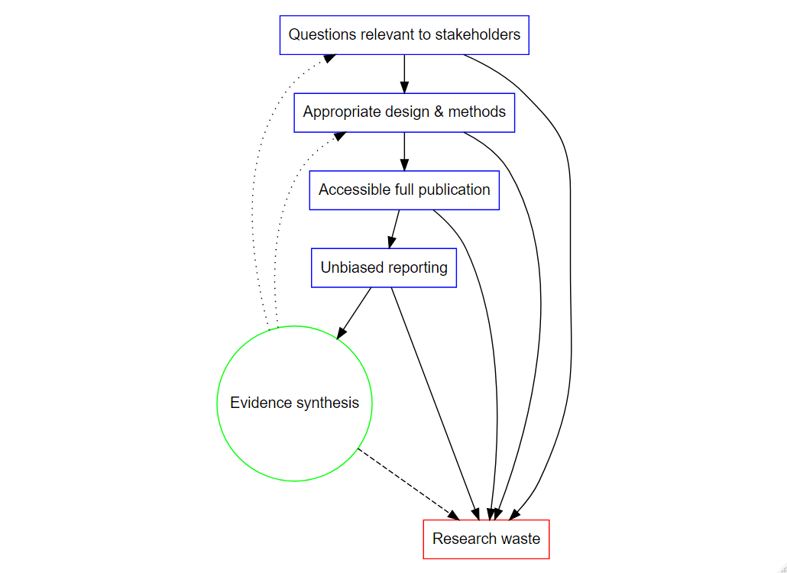

Figure 1

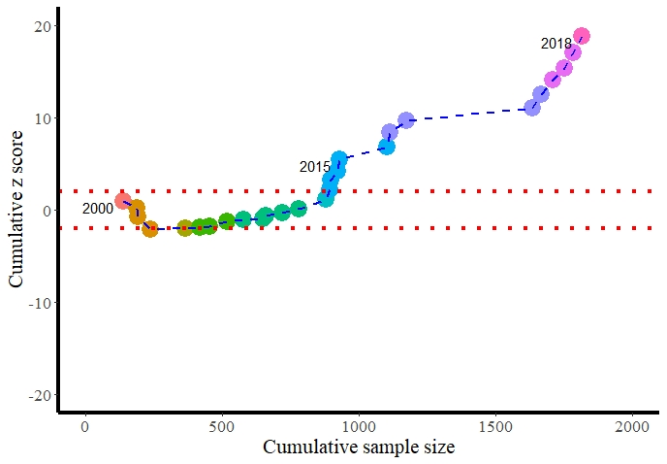

Figure 2

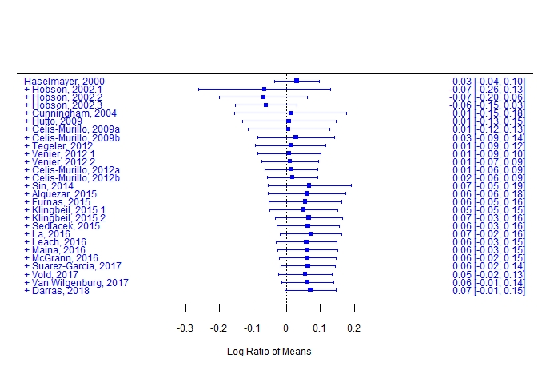

Figure S1

Supplementary Table 1.

|  |  |  |
| --- | --- | --- |
| **Research Stage** | **Examples of potential for research waste** | **Where ecology and conservation can reduce waste** |
| Questions relevant to stakeholders | Irrelevant questions asked  Previous knowledge not properly taken into account | Co-development of research questions with stakeholders  Make use of evidence synthesis methods (e.g. cumulative meta-analysis, systematic mapping, systematic reviews, meta-analysis) to identify questions that are not satisfactory answered |
| Appropriate design and methods | Study poorly designed, under-powered (or over-powered. etc.)  Using inappropriate statistical tools (including overfitting etc.)  Previous knowledge not taken into account  Questionable research practices3 lead to poor quality research | Use simulations or power-analysis prior to undertaking data collection. Predefine effect size of interest with stakeholders (i.e do not rely on rules of thumb for “statistical significance”)  Better training of early-career researchers in methods. Open code and data to ensure reproducibility of methods  Make use of evidence synthesis methods (e.g. cumulative meta-analysis, systematic mapping, systematic reviews, meta-analysis) to identify questions that are not satisfactory answered  Open science (open methods and data, reproducible methods, sharing code, etc.)  Better training of early-career researchers in methods of open science and evidence synthesis. |
| Accessible full publication | Publications not available to practitioners and decision makers | Open access publishing |
| Unbiased reporting | Lack of open data  Hypothesising after the results are known  *p*-hacking  File Drawer syndrome (only some studies are published) | Open science (open methods and data, reproducible methods, sharing code, etc.)  Pre-registration of hypotheses  Open science (open methods and data, reproducible methods, sharing code, etc.)  Pre-registration of hypotheses and methods. Open publishing (including preprints) |
| Evidence synthesis | Research not designed or presented in the context of the existing knowledge | Using systematic reviews, systematic maps, meta-analysis, etc. to shape research priorities. Research gluts should be synthesised providing evidence to relevant stakeholders. Research gaps should be the focus of primary studies. |